CDW & Iceberg Workshop Student Guide

Revision History **2**

Introduction **3**

**Labs summary** **3**

**Lab 0 - Initial setup** **4**

Pre-requisites 4

Getting Connected 4

Dataset for the workshop 5

Data Model 5

Tables 6

Initial Setup 6

**Lab 1 - Data Exploration** **8**

**Demo 1 – Auto-Scaling, Auto-Suspend & Caching Cloudera DataWarehouse** **18**

**Demo 2– Security & Governance with Ranger & Atlas** **25**

**Demo 3 – Data Visualization** **36**

**Lab 2 – Iceberg**  **43**

Create Iceberg Table Feature 43

Load Data into Iceberg Table 44

Migrate Existing Tables to Iceberg Tables 45

Evolution (Partition & Schema) 46

Time Travel **47**

**1. Appendix** **50**

Coming Soon (planned) 50

# 

# 

# 

# Revision History

|  |  |  |  |
| --- | --- | --- | --- |
| **Revision** | **Date** | **Author** | **Comments** |
| 1 |  | Amit | Initial Version |
| 1.1 |  | Sandeep | Updated as per CDP Version |
|  |  |  |  |
|  |  |  |  |
|  |  |  |  |

# Introduction

In this workshop, we will introduce you to the key capabilities of Cloudera Data Warehouse experience. Cloudera Data Warehouse is an auto-scaling, highly concurrent and cost effective analytics service that ingests high scale data anywhere, from structured, unstructured and edge sources. It supports hybrid and multi-cloud infrastructure models by seamlessly moving workloads between on-premises and any cloud for reports, HUE dashboards, ad-hoc and advanced analytics, including AI, with consistent security and governance. Cloudera Data Warehouse offers zero query wait times, reduced IT costs and agile delivery.

We are going to set up Cloudera Data Warehouse on CDP Public Cloud with AWS as backend infrastructure for storage and compute. At a high level, we are going to cover below items during our workshop:

* Controlling Cost, Matching DW Supply to Demand via autosuspend, autostart
* Protecting Workloads via isolation
* Scaling Up Usage via concurrency optimizations
* Keeping Up with the Needs of Business via fast provisioning
* Meeting SLAs via automated caching
* Secure & Governance via SDX

# **Labs summary**

1. Set-up Virtual Warehouse
2. Data Exploration
3. Auto-scaling, Auto-suspend & Caching
4. Security & Governance with Ranger & Audit
5. Data Visualization

# Lab 0 - Initial setup

## Pre-requisites

1. Laptop with a supported OS (Windows 7 not supported) or Macbook.
2. A modern browser - Google Chrome (IE, Firefox, Safari not supported).

## Getting Connected

**URL**: Will be shared by the instructor

**User:** Will be shared by the instructor

**Password:** Will be shared by the instructor

## 

Open the URL provided by the instructor on your browser. You will get the following . Please inform your instructor and share your machine’s IP in case you are NOT able to get the following page.

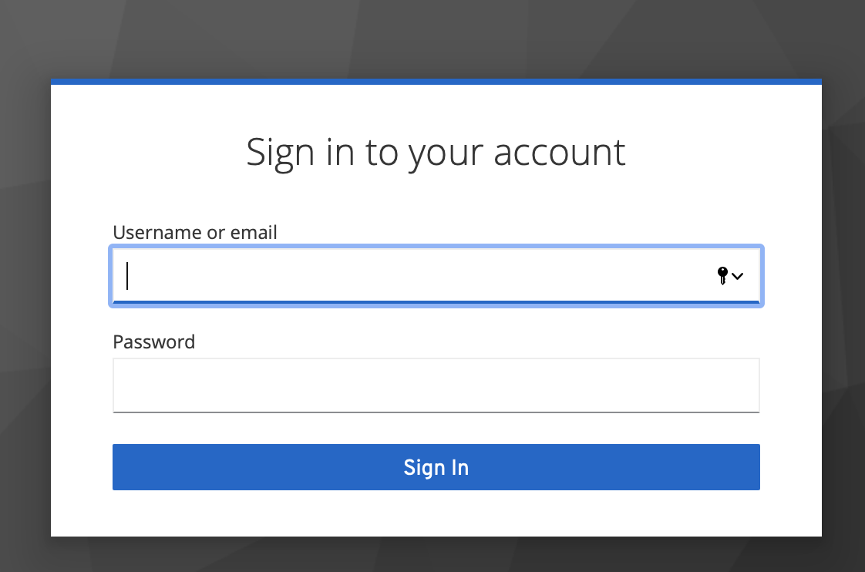

Enter the username and password shared by your instructor. You should be able to get the following home page of CDP Public Cloud.

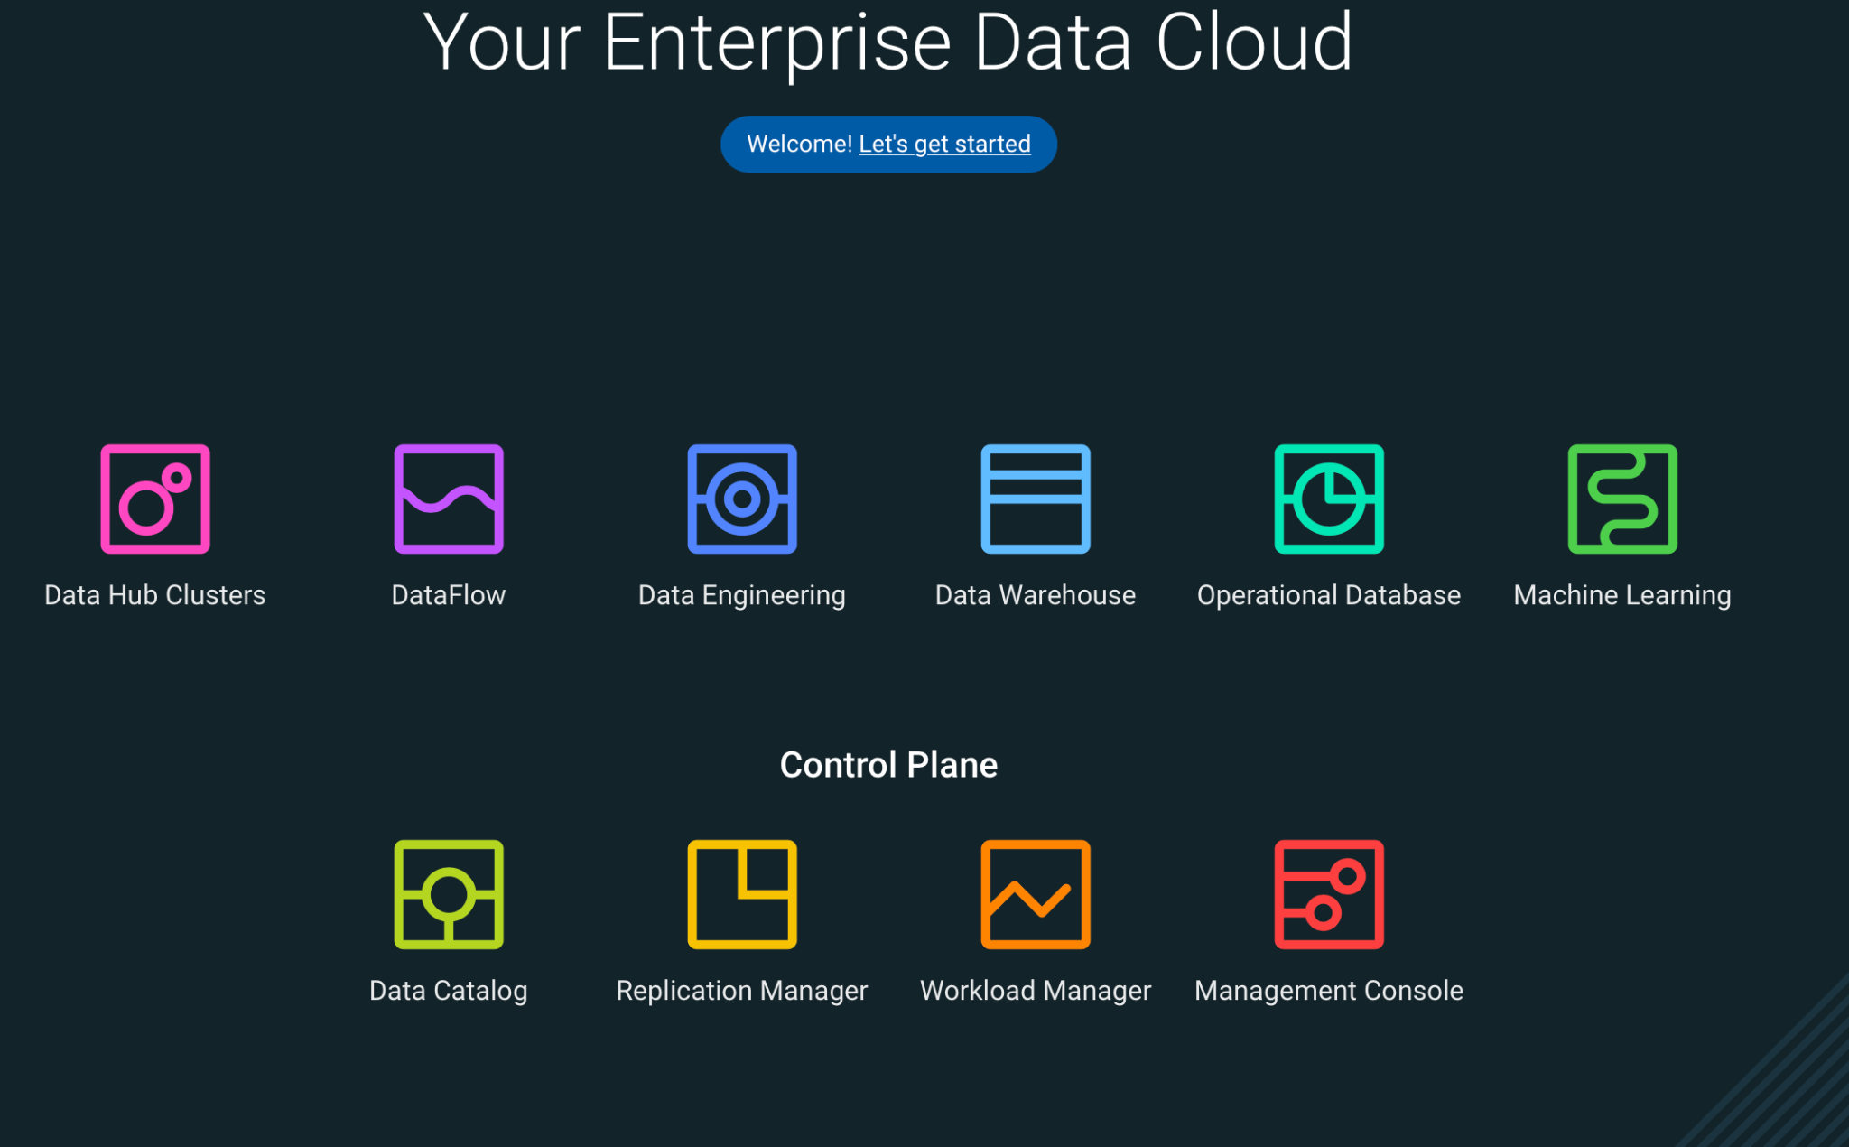

## Dataset for the workshop

In this exercise, we will work with an existing data set containing airline data. The data consists of flight arrival and departure details for all commercial flights within the USA, from October 1987 to April 2008. This is a large dataset: there are nearly 120 million records in total, and it takes up 1.6 GB of space compressed, and 12 GB uncompressed. The objective is to show how you can easily work with your data in a secure, scalable and cost-effective data warehouse: Cloudera Data Warehouse

The goal is to build a DW application that mirrors the applications that our customers run on our platform (or that we want them to migrate to our platform). We will navigate through the data and use some DW concepts like SCD (Slow Change Dimension), Facts, Materialized Views, etc.

## Data Model

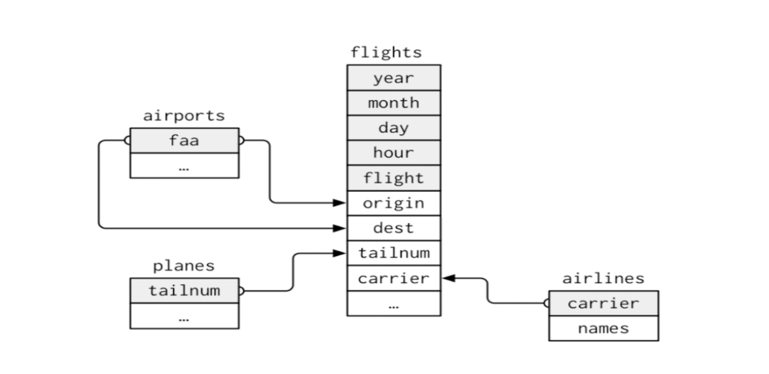

*faa ⇒ iata

*carrier ⇒ code

## Tables

The database consists of four tables:

**Dimensions:**

* **Airports** - Table with airport information ("carrier" column name is changed to "code" in this exercise).
* **Planes** - Table with planes details.
* **Airlines** - Table with airline information ("faa" column name is changed to "iata" in this exercise).

**Fact:**

* **Flights** - Table containing flights between a period and with details of cancelled flights.

## Initial Setup

To make this workshop efficient, we have already created necessary prerequisites for users to start working on features of Cloudera Datawarehouse. Here are steps that are already done:

1. Workshop data is already loaded in S3 bucket
2. CDP environment is already created
3. The necessary Database Catalog (kind of Hive metastore) has also been created.

******** Screenshots of environment & Data Catalogue *********

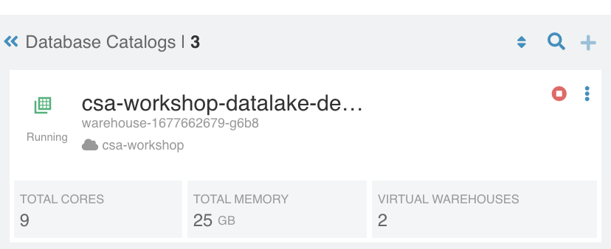

# 

# Lab 1 - Data Exploration

In this lab, you will explore some dataset using a different editor available within CDP

**STEP 1** : Information on abfs files

Copy file into your abfs storage using abfs

azcopy copy '<local path>/cdw_workshop' 'https://<storageaccount>.blob.core.windows.net/data/?<SAS token> --recursive

You will be using a dataset that’s already loaded into S3 buckets as ORC files. Here is how these data is placed in abfs data container - **abfs://data@<storageaccount>.dfs.core.windows.net/cdw_workshop**

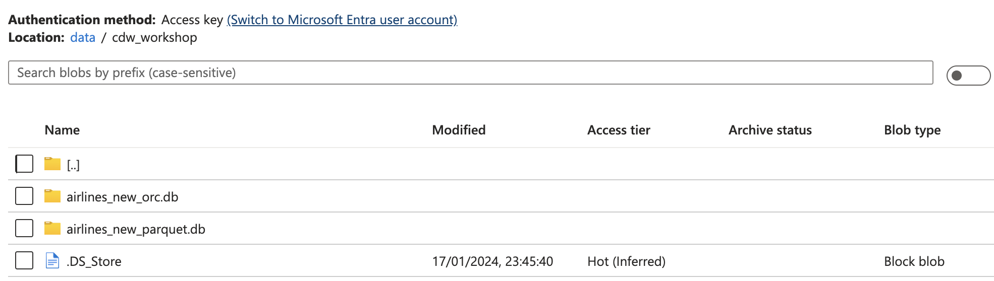

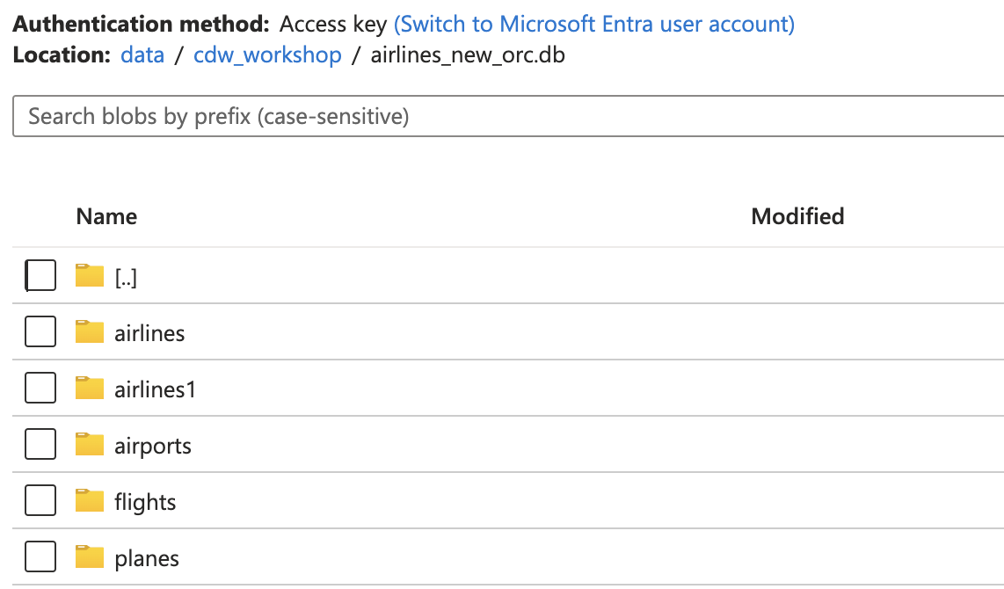

Since the files are stored in ORC format for faster querying & access, you won't be able to read these files as standard ASCII

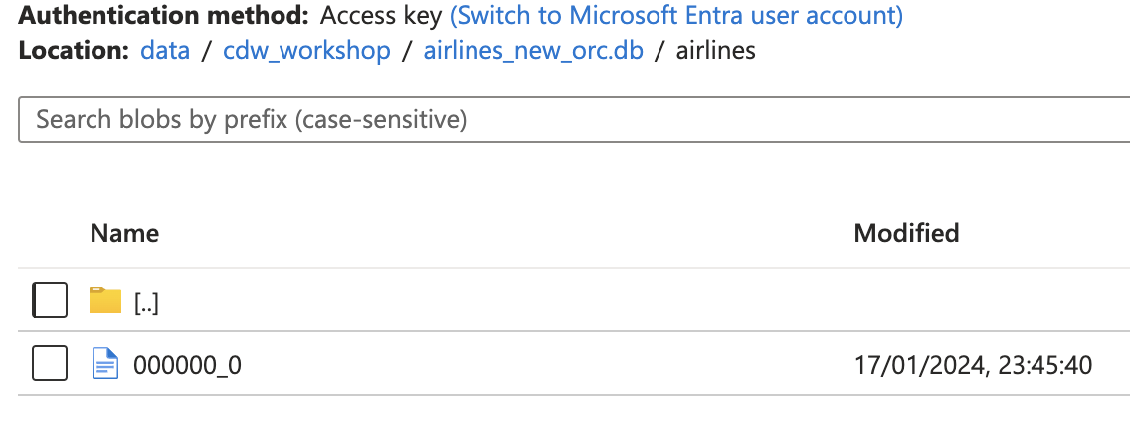

Also Update your Hue browser to use you ABFS Path – Using below setting

Note :- Without below setting you will not be able to access data from ABFS

https://docs.cloudera.com/cdw-runtime/cloud/using-hue/topics/dw-hue-enable-abfs-file-browser.html

**STEP 2** : Click on  and “Open Hue”

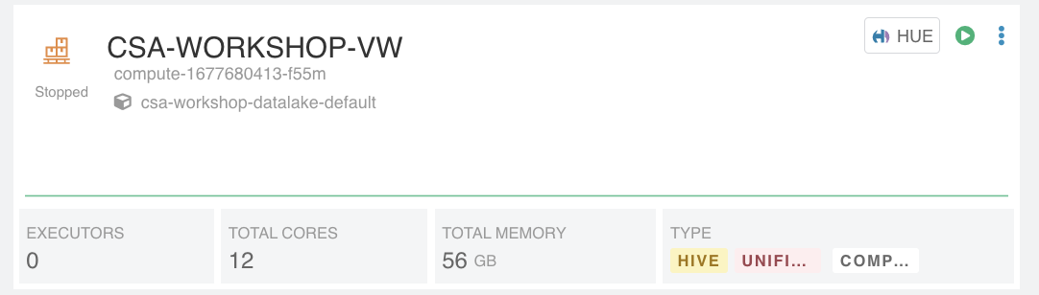

This opens-up Hue editor for you to work on your queries and do necessary analysis of your data. Provide your assigned username and password.

In Hue, click on Compose option to see an editor for writing SQLs

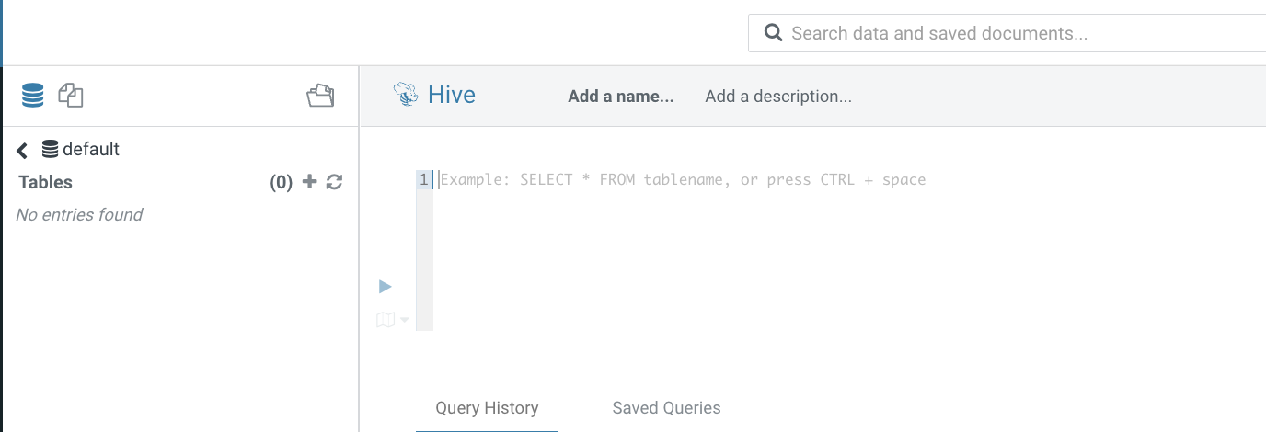

**STEP 3 :** Create external tables for airlines, airports, planes & flights. Please follow below syntax & change username to your assigned username.

Create a database for your username.

*create database if not exists username;*

*e.g.*

*create database if not exists muser01;*

Airlines(external):

create external table if not exists amit.airlines_ext (

code string,

description string

)

ROW FORMAT DELIMITED FIELDS TERMINATED BY ',' LINES TERMINATED BY '\n'

STORED AS ORC

LOCATION 'abfs://data@smtestaz1.dfs.core.windows.net/cdw_workshop/airlines_new_orc.db/airlines'

TBLPROPERTIES ("skip.header.line.count"="1");



Airports(external):

create external table if not exists **<username>**.airports_ext (

iata string,

airport string,

city string,

state double,

country string,

lat double,

lon double

)

ROW FORMAT DELIMITED FIELDS TERMINATED BY ',' LINES TERMINATED BY '\n'

STORED AS ORC

LOCATION 'abfs://data@smtestaz1.dfs.core.windows.net/cdw_workshop/airlines_new_orc.db/airports'

;



Planes(external):

create external table if not exists **<username>**.planes_ext (

tailnum string,

owner_type string,

manufacturer string,

issue_date string,

model string,

status string,

aircraft_type string,

engine_type string,

year int

)

ROW FORMAT DELIMITED FIELDS TERMINATED BY ',' LINES TERMINATED BY '\n'

STORED AS ORC

LOCATION 'abfs://data@smtestaz1.dfs.core.windows.net/cdw_workshop/airlines_new_orc.db/planes';



Flights(external):

create external table if not exists **<username>**.flights_ext (month int, dayofmonth int, dayofweek int, deptime int, crsdeptime int, arrtime int, crsarrtime int, uniquecarrier string, flightnum int, tailnum string, actualelapsedtime int, crselapsedtime int, airtime int, arrdelay int, depdelay int, origin string, dest string, distance int, taxiin int, taxiout int, cancelled int, cancellationcode string, diverted string, carrierdelay int, weatherdelay int, nasdelay int, securitydelay int, lateaircraftdelay int,year int)

ROW FORMAT DELIMITED FIELDS TERMINATED BY ',' LINES TERMINATED BY '\n'

STORED AS ORC

LOCATION 'abfs://data@smtestaz1.dfs.core.windows.net/cdw_workshop/airlines_new_orc.db/flights';



Check if these tables are created with necessary data. Run below commands one after another and check for results

1. *Select * from username.airlines_ext*
2. *Select * from username.airports_ext*
3. *Select * from username.planes_ext*
4. *Select * from username.flights_ext limit 10*



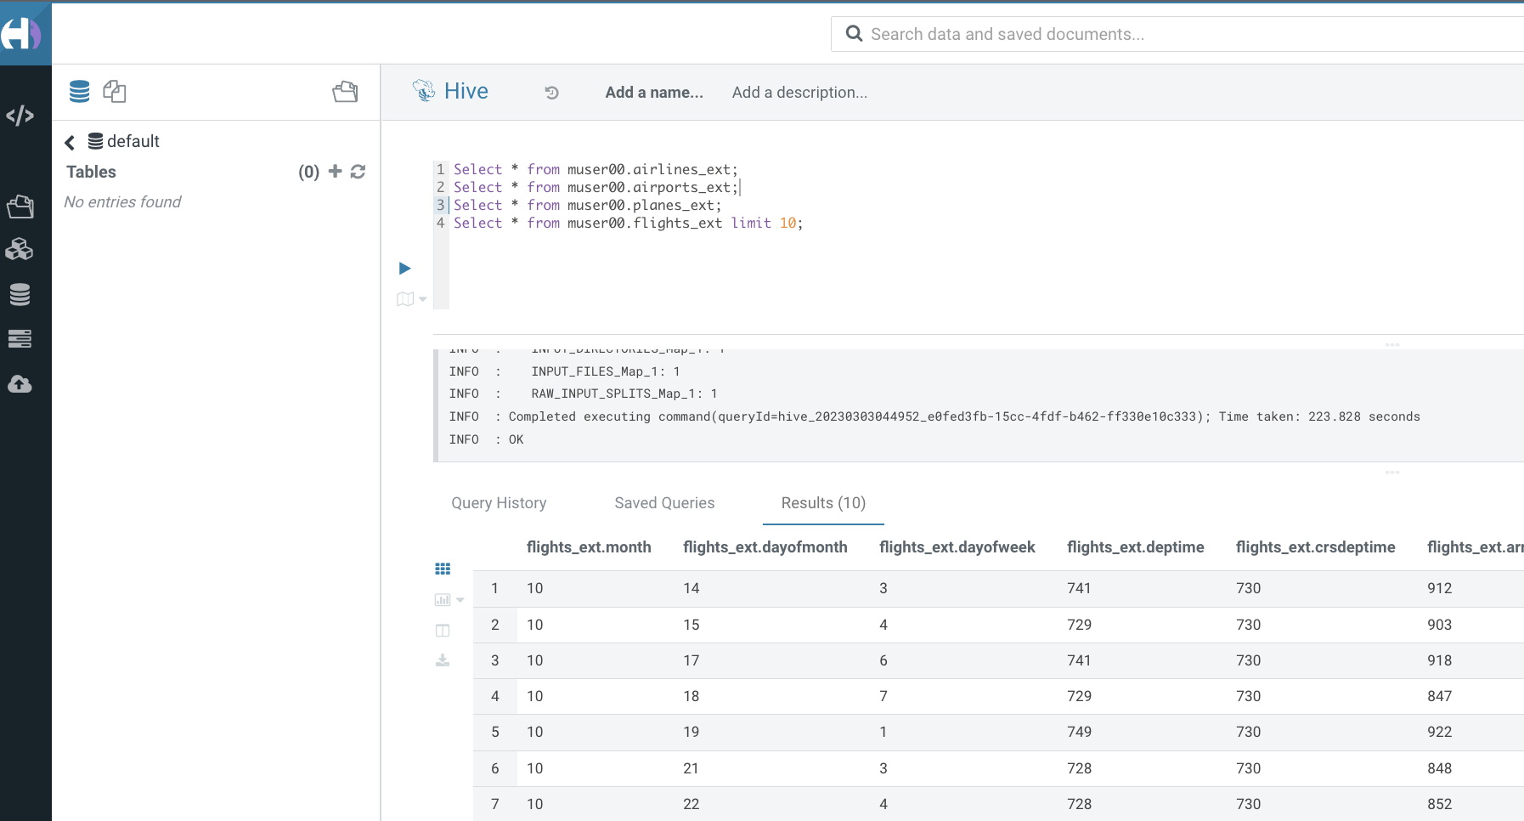

**STEP 4** : Create managed tables

-- Airlines (Managed)

*create table if not exists username.airlines (*

*code string,*

*description string*

*);*



-- Airports (Managed)

*create table if not exists username.airports (*

*iata string,*

*airport string,*

*city string,*

*state double,*

*country string,*

*lat double,*

*lon double*

*);*



-- Planes (Managed)

*create table if not exists username.planes (*

*tailnum string,*

*owner_type string,*

*manufacturer string,*

*issue_date string,*

*model string,*

*status string,*

*aircraft_type string,*

*engine_type string,*

*year int*

*);*



-- Flights (Managed)

*create table if not exists username.flights (month int, dayofmonth int, dayofweek int, deptime int, crsdeptime int, arrtime int, crsarrtime int, uniquecarrier string, flightnum int, tailnum string, actualelapsedtime int, crselapsedtime int, airtime int, arrdelay int, depdelay int, origin string, dest string, distance int, taxiin int, taxiout int, cancelled int, cancellationcode string, diverted string, carrierdelay int, weatherdelay int, nasdelay int, securitydelay int, lateaircraftdelay int,year int);*



**STEP 5** : Load data into managed tables from external tables

-- Airlines (Insert Managed)

***insert overwrite table username.airlines***

***select code, description from username.airlines_ext;***

-- Airports (Insert Managed)

***insert overwrite table username.airports***

***select  iata, airport, city, state, country, lat, lon from username.airports_ext;***

-- Planes (Insert Managed)

***insert overwrite table username.planes***

***select  tailnum, owner_type, manufacturer, issue_date, model, status, aircraft_type, engine_type, year from username.planes_ext;***



-- Flights (Insert Managed) (Please note, this insert query may take some time due to big data set that needs to be inserted into managed table)

***INSERT OVERWRITE TABLE username.flights SELECT * FROM username.flights_ext;***



Check if these managed tables are created with necessary data. Run below commands one after another and check for results

*Select * from username.airlines*

*Select * from username.airports*

*Select * from username.planes*

*Select * from username.flights limit 10*



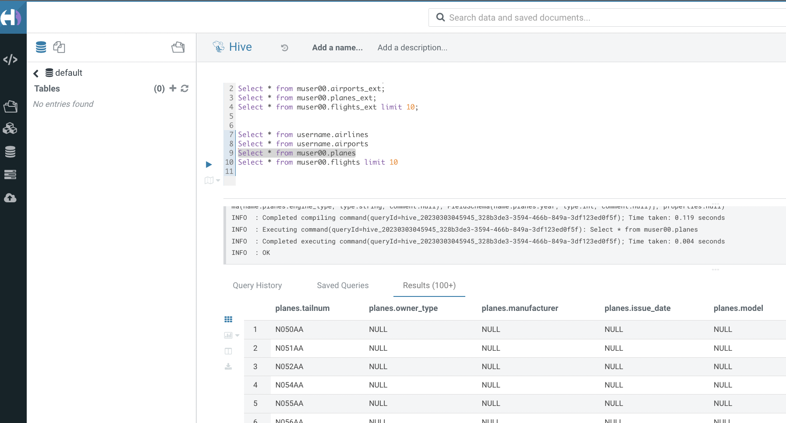

**STEP 6** : Create primary keys and foreign keys

This is done so that Materialized View rewriting can be done properly later on. Also, in general, specifying these constraints helps the query planner to build more effective plans. But note that these constraints are not actually enforced (i.e. no referential integrity checks are done). Be sure to replace all “username” instances with your assigned username.



*ALTER TABLE username.planes ADD CONSTRAINT planes_pk_username PRIMARY KEY (tailnum) DISABLE NOVALIDATE;*

*ALTER TABLE username.flights ADD CONSTRAINT planes_fk_username FOREIGN KEY (tailnum) REFERENCES username.planes(tailnum) DISABLE NOVALIDATE RELY;*

*ALTER TABLE username.airlines ADD CONSTRAINT airlines_pk_username PRIMARY KEY (code) DISABLE NOVALIDATE;*

*ALTER TABLE username.flights ADD CONSTRAINT airlines_fk_username FOREIGN KEY (uniquecarrier) REFERENCES username.airlines(code) DISABLE NOVALIDATE RELY;*

*ALTER TABLE username.airports ADD CONSTRAINT airports_pk_username PRIMARY KEY (iata) DISABLE NOVALIDATE;*

*ALTER TABLE username.flights ADD CONSTRAINT airports_orig_fk_username FOREIGN KEY (origin) REFERENCES username.airports(iata) DISABLE NOVALIDATE RELY;*

*ALTER TABLE username.flights ADD CONSTRAINT airports_dest_fk_username FOREIGN KEY (dest) REFERENCES username.airports(iata) DISABLE NOVALIDATE RELY;*



**STEP 6** : Materialized View in Hive Virtual Warehouse – Initial setup Step

Now that our dataset is ready, from this place it is common to do things like build complex reports, do ad hoc analysis, run operational HUE dashboards, and create downstream data marts for subject specific uses. This scenario is commonly referred to as an Enterprise Data Warehouse - all the enterprise data is cleaned, in one place, and trustworthy.

In this layer it is common to use Materialized Views to accelerate BI performance. Hive supports Materialized Views and has the ability to rewrite queries automatically if they can take advantage of an existing materialized view. It utilizes Apache Calcite to perform partial and full rewrites. The rich SQL syntax support in Hive is also very useful here, as there is typically a very wide array of SQL needed in this layer. And finally, with HUE dashboarding scenarios in particular, the Hive query result cache can provide a big performance boost.

In this exercise we'll use a BI generated query and try to improve the performance using the Materialized View feature.

Open HUE in the Hive Virtual Warehouse that was used above, and do the following:

Execute the following BI query two times in a row:

*SELECT*

*SUM(`flights`.`cancelled`) AS `col_1`,*

*SUM(1) AS `col_2`,*

*MIN(`airlines`.`description`) AS `col_3`,*

*`airlines`.`code` AS `code`*

*FROM*

*`username`.`flights` `flights`*

*JOIN `username`.`airlines` `airlines` ON (`flights`.`uniquecarrier` = `airlines`.`code`)*

*WHERE*

*(`flights`.`month` = 12)*

*GROUP BY*

*`airlines`.`code`;*



Go to HUE query history and view the details for the queries that you've just executed. You can see the tables read and a visual explain plan for the query. Note the path that was followed to execute the query and the time spent. Also, note that in the second query, the results were returned much faster and the visual explain plan is simple. This is because the second execution simply read from the query result cache.

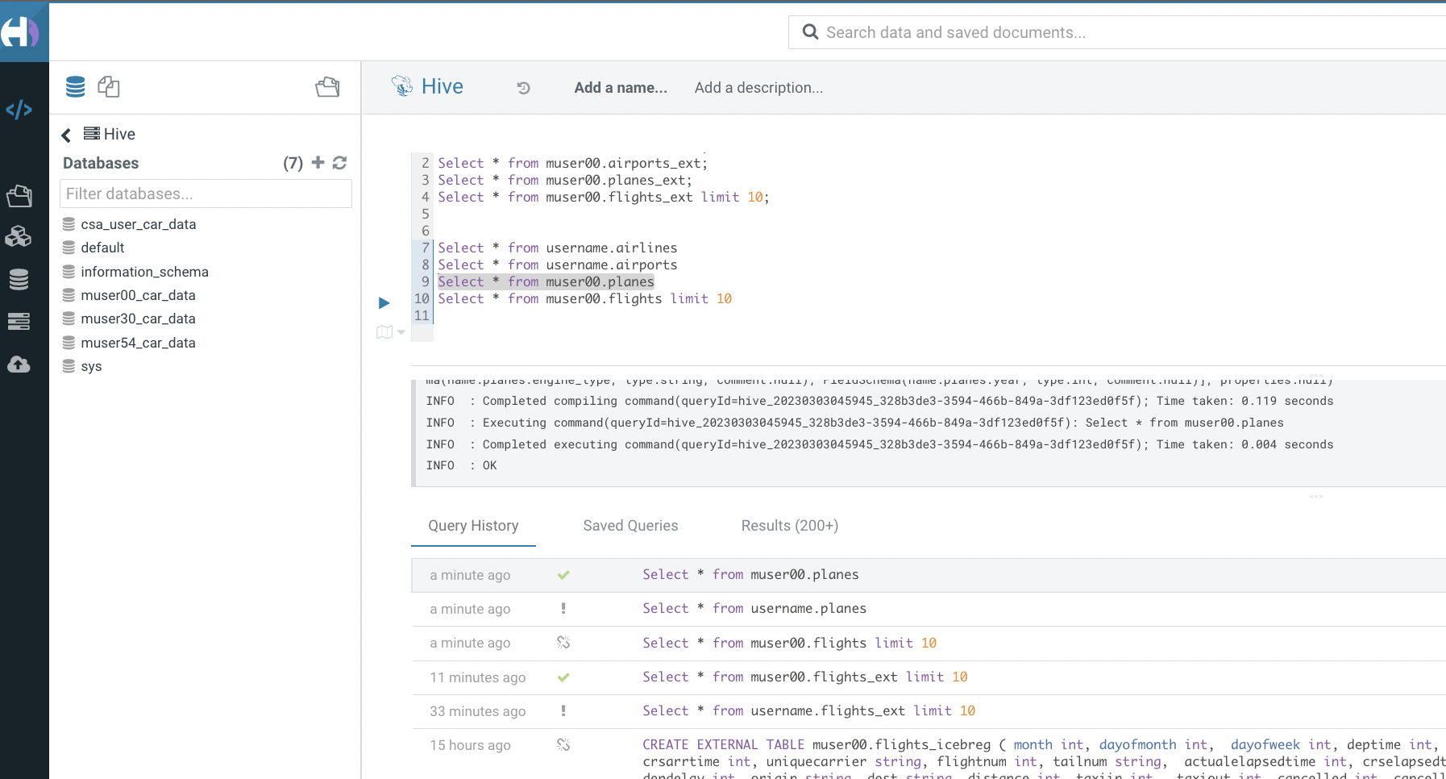

**STEP 7** : Materialized View in Hive Virtual Warehouse – Create step

Create a Materialized View that selects the columns used by the query in STEP 6 and performs the same join, no need to group or perform any "group by" or "where" in this step

*CREATE MATERIALIZED VIEW username.traffic_cancel_airport as*

*SELECT*

*`flights`.`cancelled`,*

*`airlines`.`description`,*

*`airlines`.`code` AS `code`,*

*`flights`.`month` AS month,*

*`flights`.`year` AS year*

*FROM*

*`username`.`flights` `flights`*

*JOIN `username`.`airlines` `airlines` ON (`flights`.`uniquecarrier` = `airlines`.`code`);*



Execute the BI query again, this time disabling the query result cache to force usage of the materialized view:

*SET hive.query.results.cache.enabled=false;*

*SELECT*

*SUM(`flights`.`cancelled`) AS `col_1`,*

*SUM(1) AS `col_2`,*

*MIN(`airlines`.`description`) AS `col_3`,*

*`airlines`.`code` AS `code`*

*FROM*

*`username`.`flights` `flights`*

*JOIN `username`.`airlines` `airlines` ON (`flights`.`uniquecarrier` = `airlines`.`code`)*

*WHERE*

*(`flights`.`month` = 12)*

*GROUP BY*

*`airlines`.`code`;*



# 

# Demo 1 – Auto-Scaling, Auto-Suspend & Caching Cloudera DataWarehouse

In this lab, you will see autoscaling & auto-suspend capabilities of Cloudera DataWarehouse. Virtual Warehouses can use Hive or Impala as the underlying execution engine. Typically, Hive is used to support complex reports and enterprise HUE dashboards. Impala is used to support interactive, ad-hoc analysis. When you create a Virtual Warehouse, you set auto-scaling to make sure you have adequate resources to meet increases in demand. Auto-scaling settings also insure that your Virtual Warehouse relinquishes resources when demand decreases to save costs.

When you create new Virtual Warehouse instances, you can set auto-scaling thresholds. These thresholds set limits on automatic cluster scaling to meet workload demands. Setting these limits prevents warehouses from consuming too many resources when workload demands increase or decrease.

In Cloudera Data Warehouse (CDW) service, when you tune Hive-LLAP Virtual Warehouses, you set the auto-suspend timeout, the minimum and maximum number of nodes for your virtual cluster, when your cluster should scale up and down, and whether to use query isolation for scan-heavy, data-intensive queries.

Here is what we set as Auto-scale & Auto-suspend properties for our DataWarehouse:

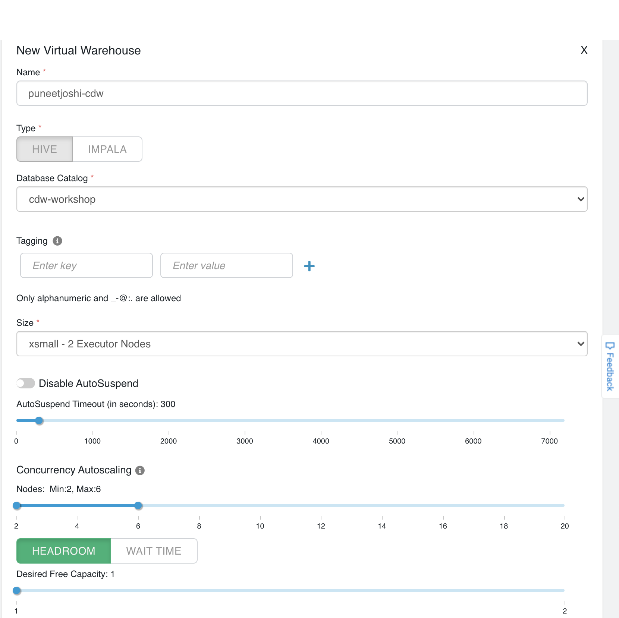

**STEP 1** : Auto-Susped

Since its been some time we ran our queries, Cloudera DataWarehouse has amazing capabilities to release off resources when its not in use. If you look at your Virtual Warehouse screen, you will notice that the current node count is 0. Which means, it has auto-suspended all the resources. As per our settings, if our Virtual Warehouse does not see any incoming queries for more than 300 seconds, it automatically suspends all the container nodes.

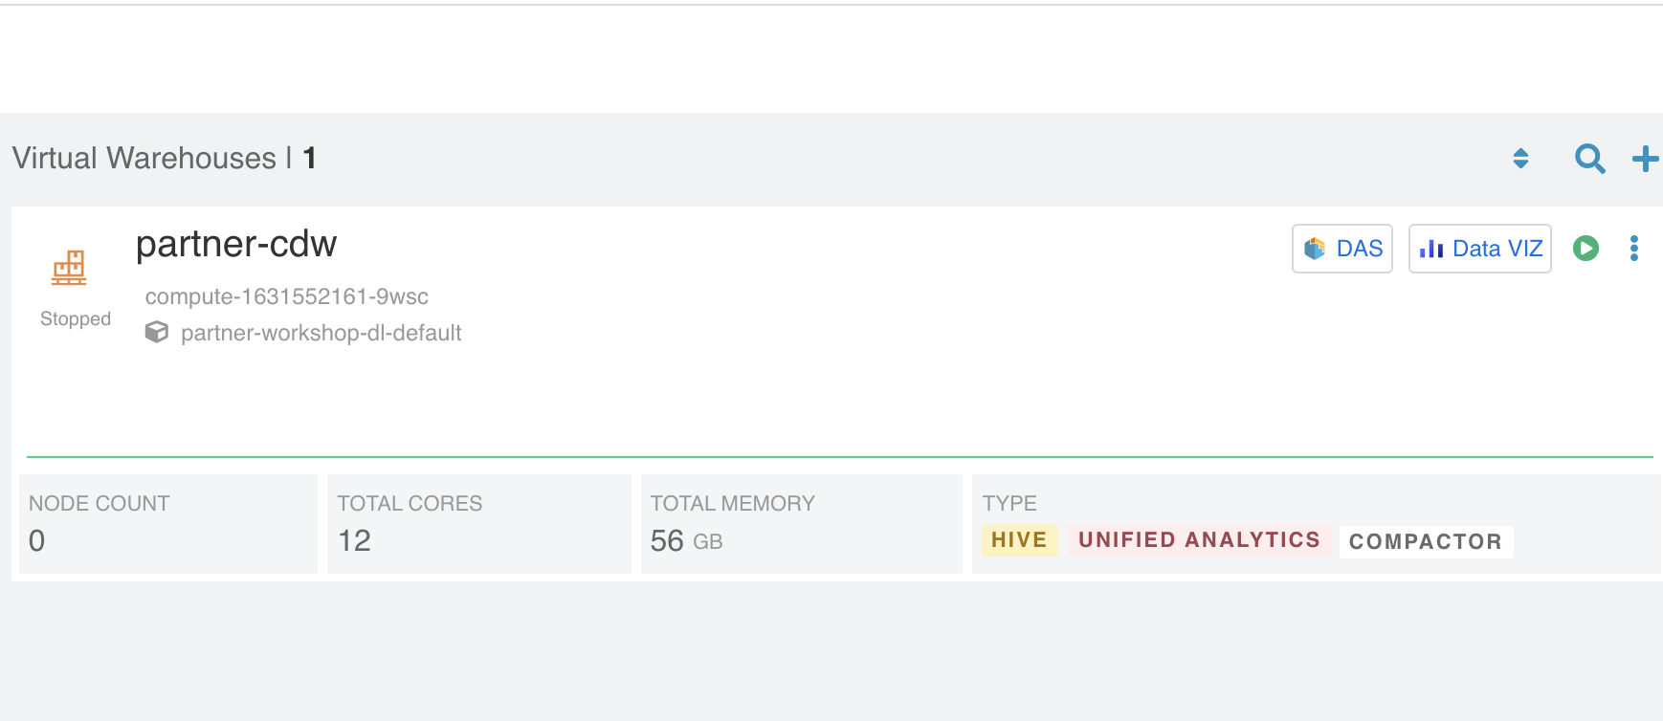

**STEP 2** : Auto-Scale

Now, lets look at Auto-scale capabilities. Click on  and “Open HUE” and open SQL editor by Clicking Compose on the left.

For us to show auto-scaling, open HUE in one another tab, so that we run complex queries parallelly and see how Cloudera Virtual Warehouse auto-scales

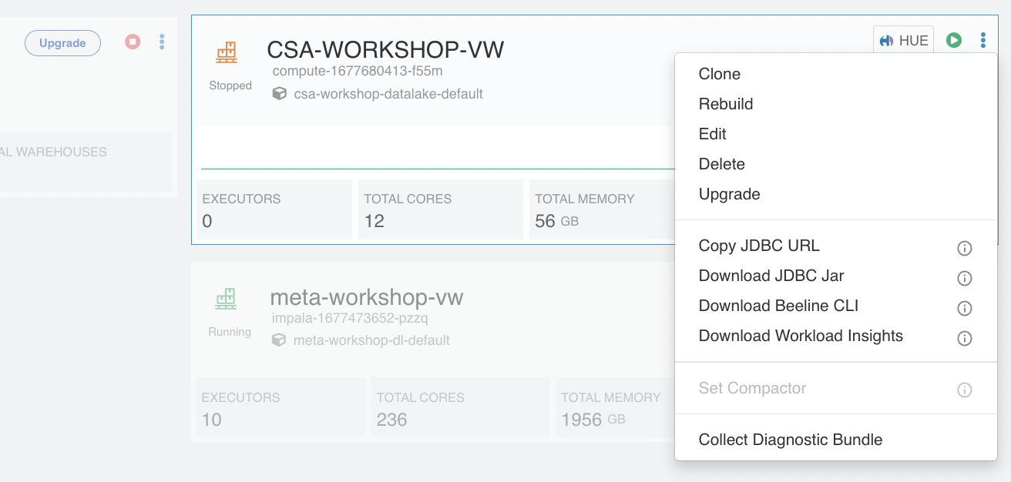

Choose your database in the databases section in both the HUE windows you have opened

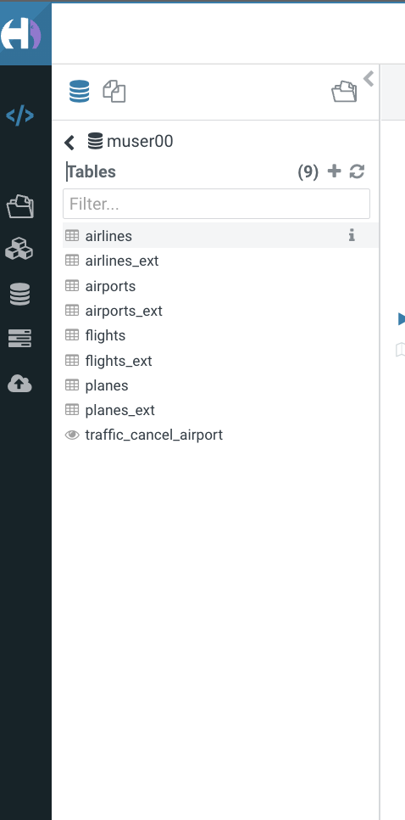

In the 1st HUE query editor, run the following command:

*SELECT Avg(Cast(flights.depdelay AS DOUBLE)) AS avg_depdelay_ok,*

*flights.year AS year*

*FROM username.flights flights*

*JOIN username.airlines airlines*

*ON ( flights.uniquecarrier = airlines.code )*

*WHERE ( airlines.description = 'American Airlines Inc.' )*

*GROUP BY flights.year;*

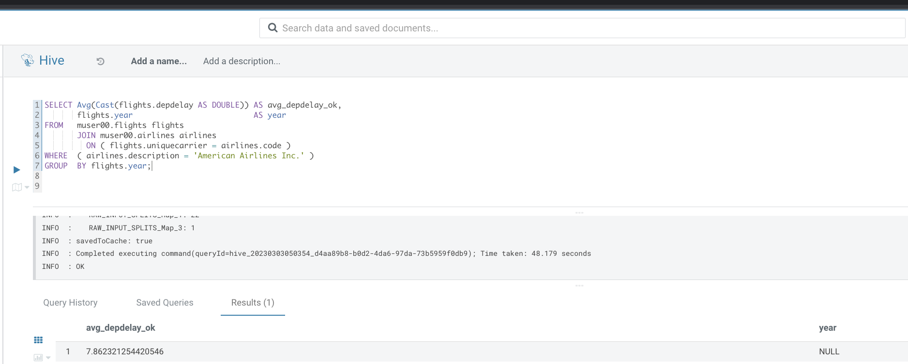

And in the 2nd HUE query editor, run the following command:

*SELECT*

*SUM(`flights`.`cancelled`) AS `col_1`,*

*SUM(1) AS `col_2`,*

*MIN(`airlines`.`description`) AS `col_3`,*

*`airlines`.`code` AS `code`*

*FROM*

*`username`.`flights` `flights`*

*JOIN `username`.`airlines` `airlines` ON (`flights`.`uniquecarrier` = `airlines`.`code`)*

*WHERE*

*(`flights`.`month` = 12)*

*GROUP BY*

*`airlines`.`code`;*

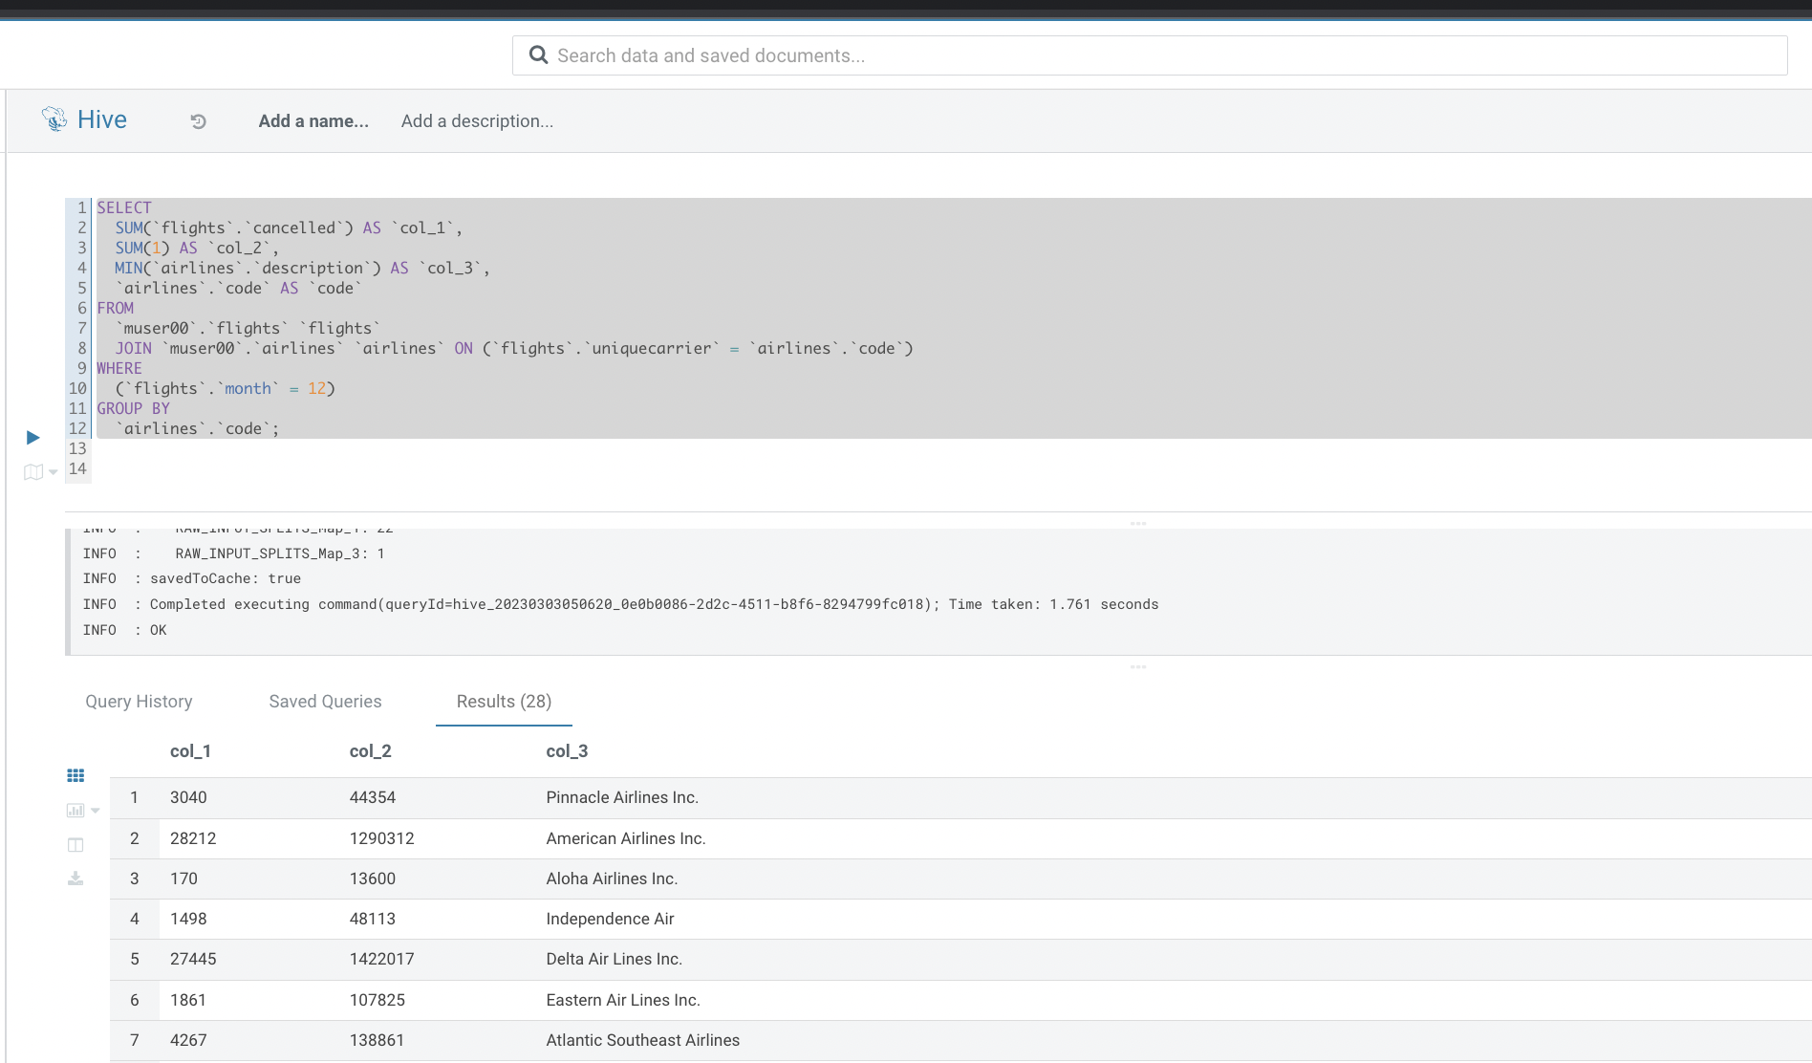

As soon as you run both the queries, quickly switch back to the Virtual Data Warehouse screen of CDP and see an increase in the number of nodes.

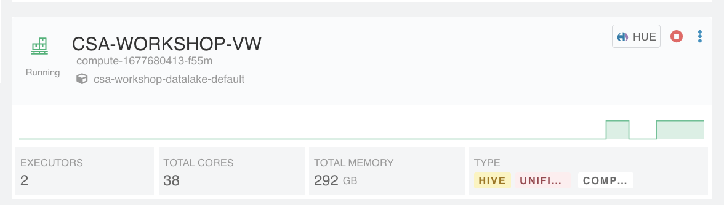

Both the queries for the first time may take some time. Now, for the 2nd time if you run the same queries with different filters, it returns results in a few seconds. Try running these queries and see how quickly your query results come out.

*SELECT AVG(CAST(flights.depdelay AS DOUBLE)) AS avg_depdelay_ok, flights.year AS year*

*FROM username.flights flights*

*JOIN username.airlines airlines ON (flights.uniquecarrier = airlines.code)*

*WHERE (airlines.description = 'United Air Lines Inc.')*

*GROUP BY flights.year*

*SELECT*

*SUM(`flights`.`cancelled`) AS `col_1`,*

*SUM(1) AS `col_2`,*

*MIN(`airlines`.`description`) AS `col_3`,*

*`airlines`.`code` AS `code`*

*FROM*

*`username`.`flights` `flights`*

*JOIN `username`.`airlines` `airlines` ON (`flights`.`uniquecarrier` = `airlines`.`code`)*

*WHERE*

*(`flights`.`month` = 11)*

*GROUP BY*

*`airlines`.`code`;*

In CDP Data Warehouse service, frequently accessed data is cached in a storage layer on S3 so that it can be quickly retrieved for subsequent queries, which boosts data warehouse performance.

# 

# Demo 2– Security & Governance with Ranger & Atlas

Apache Ranger manages access control through a user interface that ensures consistent policy administration across Cloudera Data Platform (CDP) components. Security administrators can define security policies at the database, table, column, and file levels, and can administer permissions for specific LDAP-based groups or individual users. Rules based on dynamic conditions such as time or geolocation can also be added to an existing policy rule. The Ranger authorization model is pluggable and can be easily extended to any data source using a service-based definition.

**STEP 1** : Ranger Lab

Click on left top to choose DataWarehouse

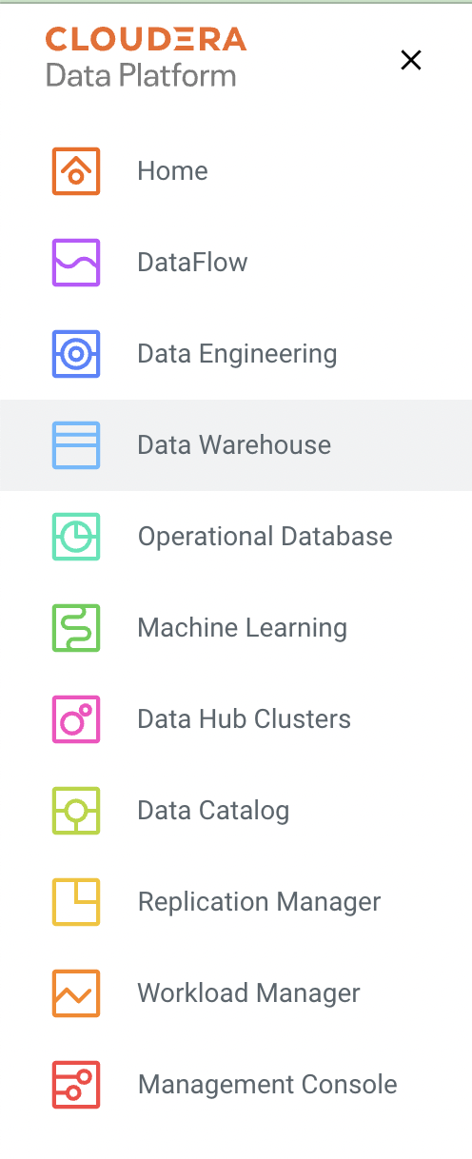

## 

Now, under your Database Catalog, Click on  and choose open Ranger

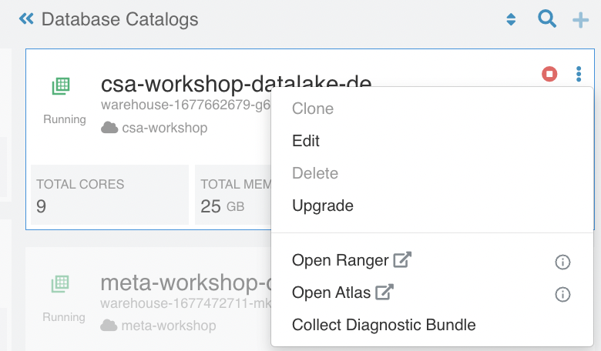

Once you get into Ranger, you will get to see a high level view of Ranger policies for all major components of CDP.

In our case, we will create Ranger policies for our Data Warehouse access. Please choose [**dwx-warehouse-1631600660-8d2z_hive**](https://partner-workshop-dl-gateway.pse-part.dp5i-5vkq.cloudera.site/partner-workshop-dl/cdp-proxy/ranger/#!/service/17/policies/0)

as shown in below screen-shot

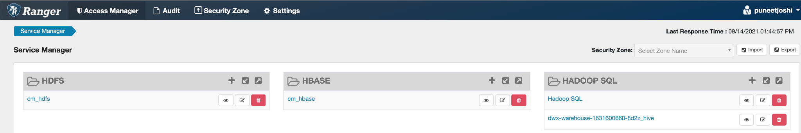

Once you get into Ranger policies for your database, you will see a view of ranger policies for Access, Masking & Row-level filters. We will work on each of these categories

**STEP 2** : Creating Ranger Access policy

Under Access tab, click on **Add New Policy**

Now, we will create an Access policy for restricting access to **Flights** table and more specifically access restriction on a column named **tailnum**.

Do not add any **Allow Conditions**. We will add only **Deny Conditions**

Refer below screen-shot to create the access policy.

\*\***Please use your database created in STEP3 of LAB2**\*\*

Add necessary permission as per below screen-shot



Save the policy.

Now, go back to HUE screen and run this query

**Select * from flights**

As you can see, you will see access restriction on flights column tailnum

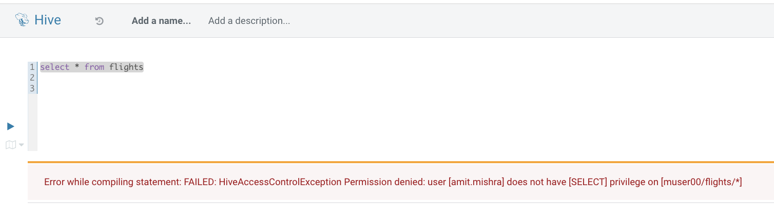

**STEP 3** : Creating Masking policy

Click on Masking tab and Add New Policy

Now, we will create a masking policy to mask Longitude column in Airport table. Create the policy as per the screen-shot below. Select your username assigned. And also choose Access type and Masking option as mentioned below.

\*\***Please use your Hive database created in STEP3 of LAB2**\*\*

Save the policy.

Now, go back to HUE and run the query and the masking live in action

**Select * from airports**

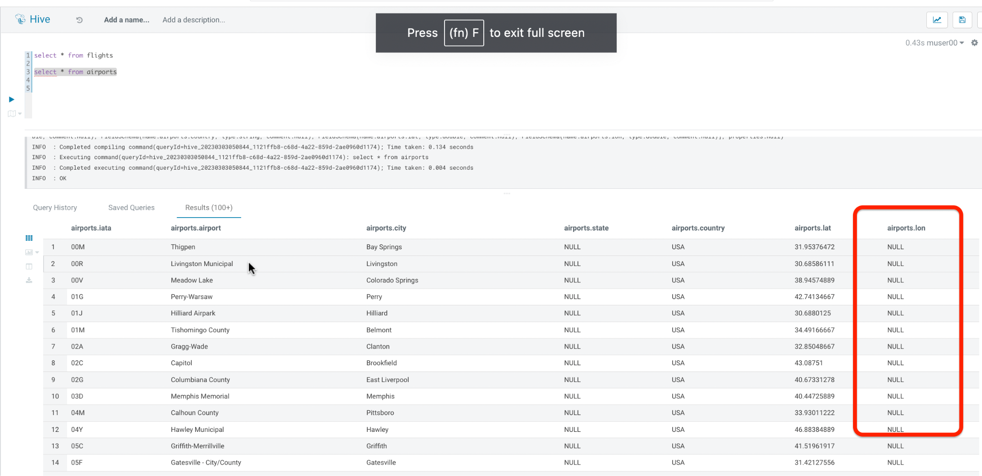

Similarly, we can also create Row-level filters to restrict access at a row-level.

**STEP 4** : Atlas lab for Governance

Apache Atlas provides scalable governance for Enterprises that is driven by metadata. Atlas, at its core, is designed to easily model new business processes and data assets with agility. This flexible type system allows exchange of metadata with other tools and processes within and outside of the Cloudera stack, thereby enabling platform-agnostic governance controls that effectively address compliance requirements

Now, under your Database Catalog, Click on  and choose open Atlas

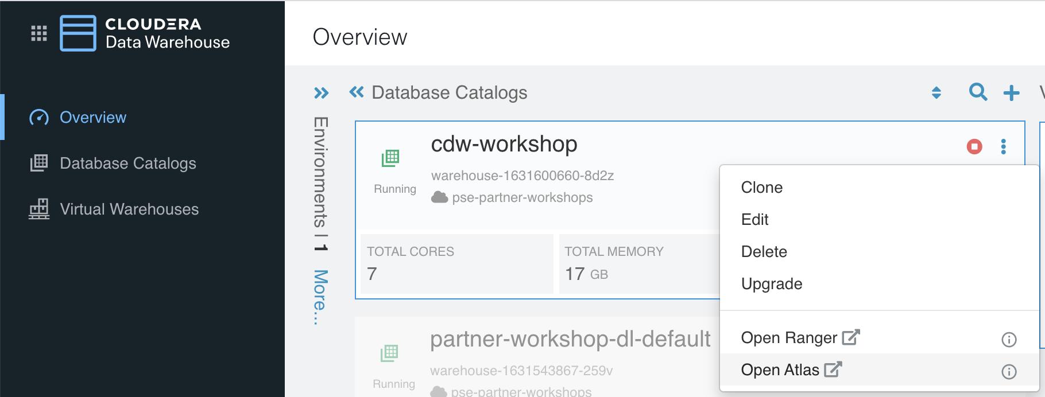

This opens-up Atlas page for you

Now, in the search by type, select hive_table as per below screen-shot and hit search

You will see search results coming now. All Hive tables in your CDP environment.

Now, bottom of the page, move forward to next pages to see all hive tables you created during previous labs

Against your username, you will see all hive tables you created during the lab.

Now, click on the materialized view you created **traffic_cancel_airport**

Go through the properties for this materialized view the Atlas has automatically captured.

Now, go back to your search results and choose flights table

Look at all the properties and click on Lineage. Spend some time to click on lineage results and how Atlas has captured lineage on how **flights** table got created

# Demo 3 – Data Visualization

In this lab you will get an opportunity to explore and work with inbuilt Data Visualization capability of the CDP platform. To execute this lab we have created a default warehouse with Visualization enabled.

**Step 1**: Navigate back to Data Warehouse home page.

Search for “cdw-workshop-default” using the search option. Below is the screen shot.

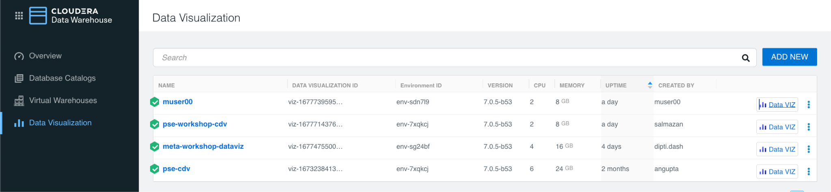

Click on Data Viz it will take you to the home page of data visualization offering.

Spend some time exploring the different options available . Especially the sample HUE dashboards.

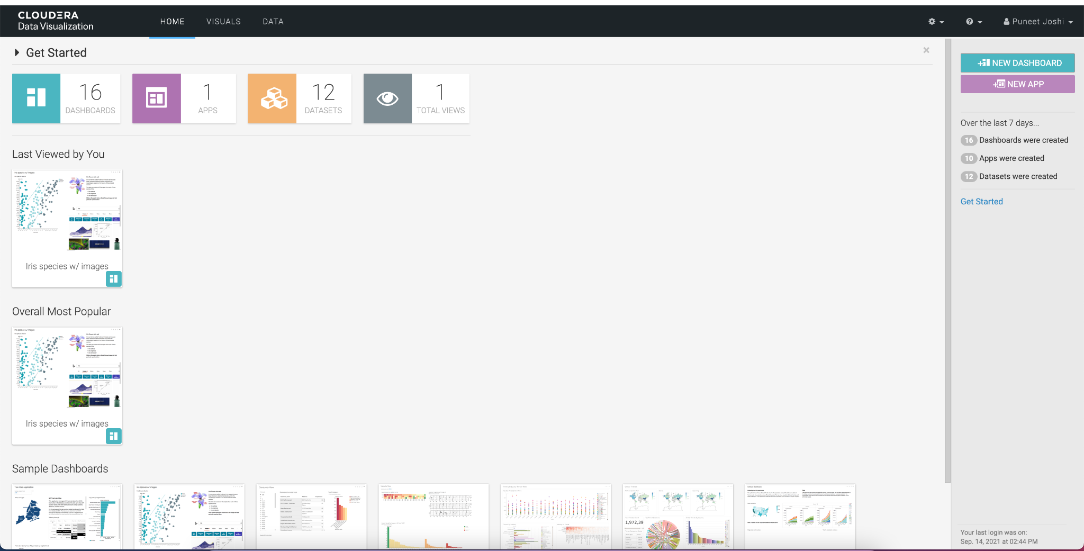

Let’s create our own HUE dashboard and see how simple it is to create a HUE dashboard from the data which we created in our previous labs. Before proceeding with this we need to disable the ranger policy which we created to restrict access to the ‘tailnum’ column.

**Step 2**: Navigate to the “Data” tab on the screen.

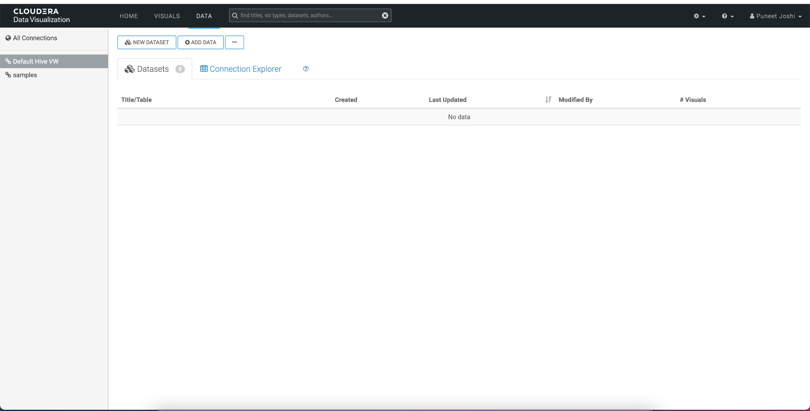

Click on “New Dataset” to add source data for our HUE dashboard.

**Step 3**: Add the data set as per below screenshot.

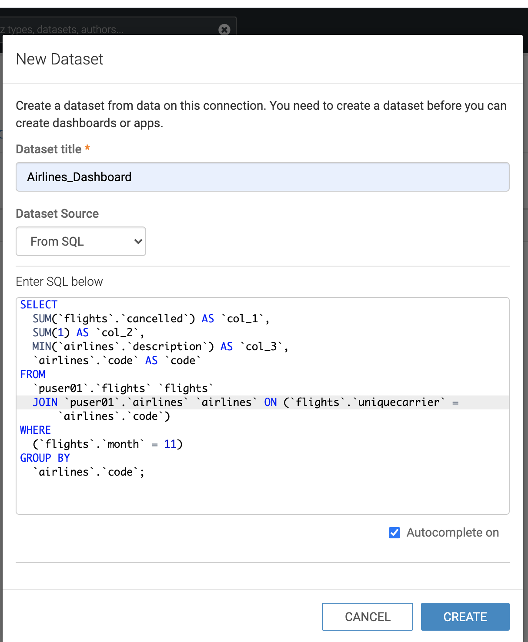

Use the below SQL after replacing your username.

*SELECT*

*SUM(`flights`.`cancelled`) AS `sum_flights_cancelled`,*

*SUM(1) AS `col_2`,*

*MIN(`airlines`.`description`) AS `min_airline_description`,*

*`airlines`.`code` AS `code`*

*FROM*

*`muser00`.`flights` `flights`*

*JOIN `muser00`.`airlines` `airlines` ON (`flights`.`uniquecarrier` = `airlines`.`code`)*

*WHERE*

*(`flights`.`month` = 11)*

*GROUP BY*

*`airlines`.`code`;*

**Step 4**: Once created click on the name of the newly created dataset to get the details page of the dataset.

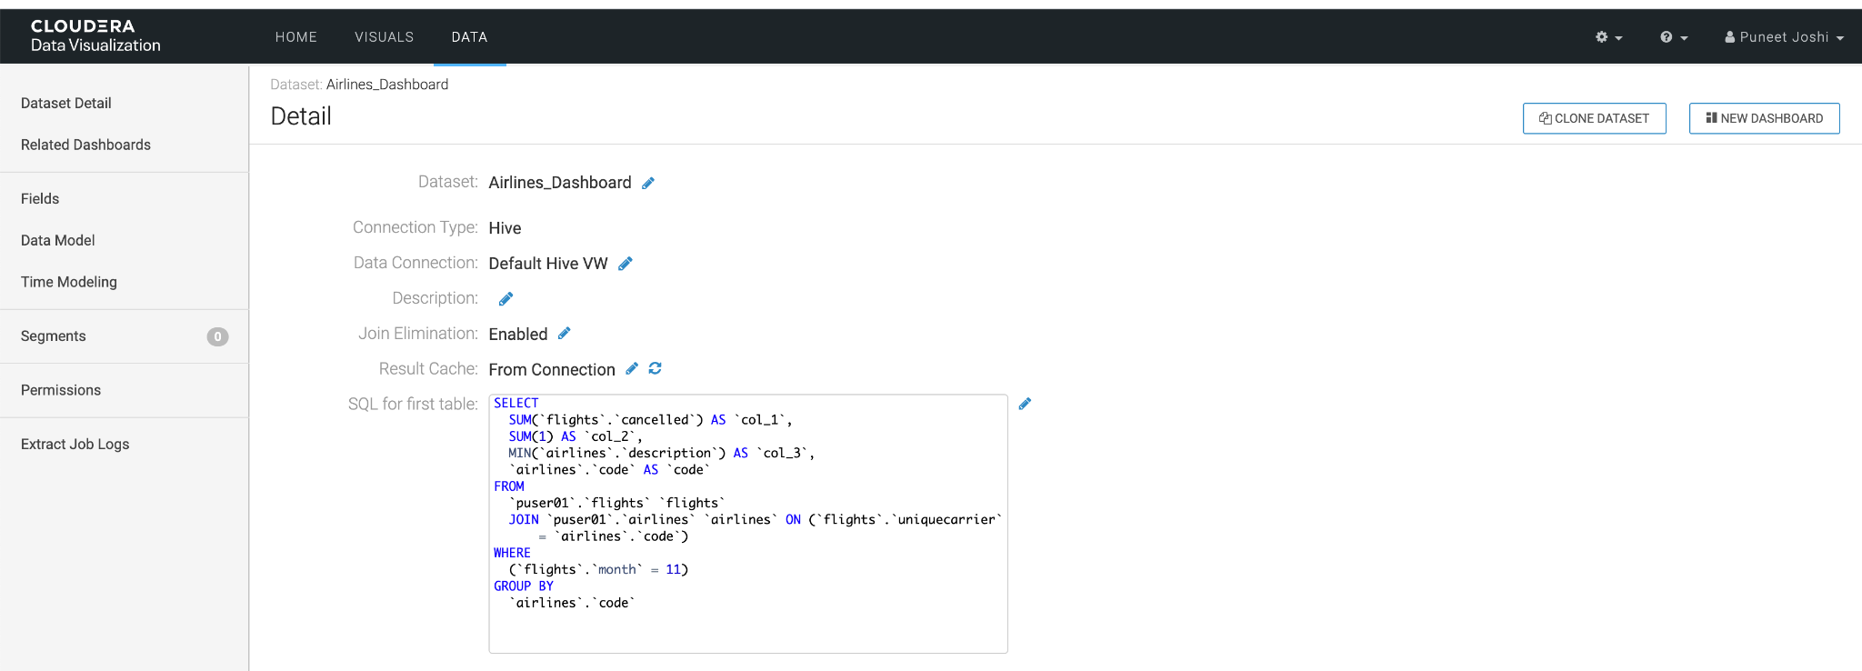

**Step 5** :Click on 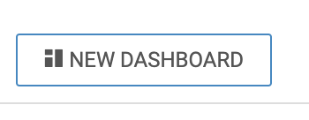 to create a HUE dashboard from the output of the above SQL query.

**Step 6** : After entering the name and sub title of the HUE dashboard . Click on “Visuals” to add rich visualization in our HUE dashboard.

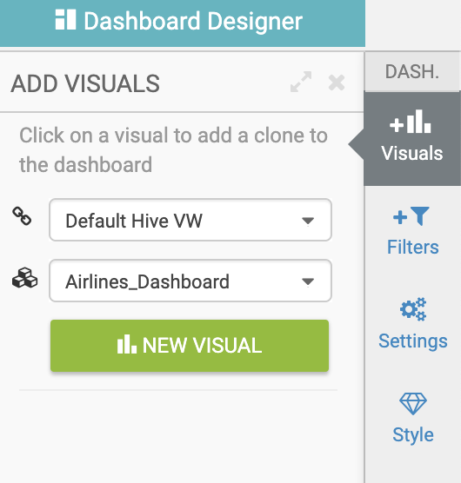

Add your desired visual to the HUE dashboard from the available ones. For illustration purposes we are going with Pie Chart to display the output of our SQL.

**Step 7** : Enter details as per below screenshot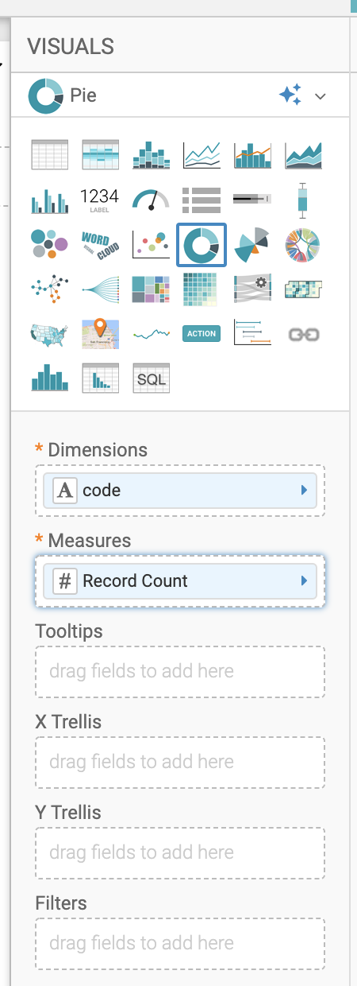.

Click on “Refresh Visual” to see output which will be similar to below.

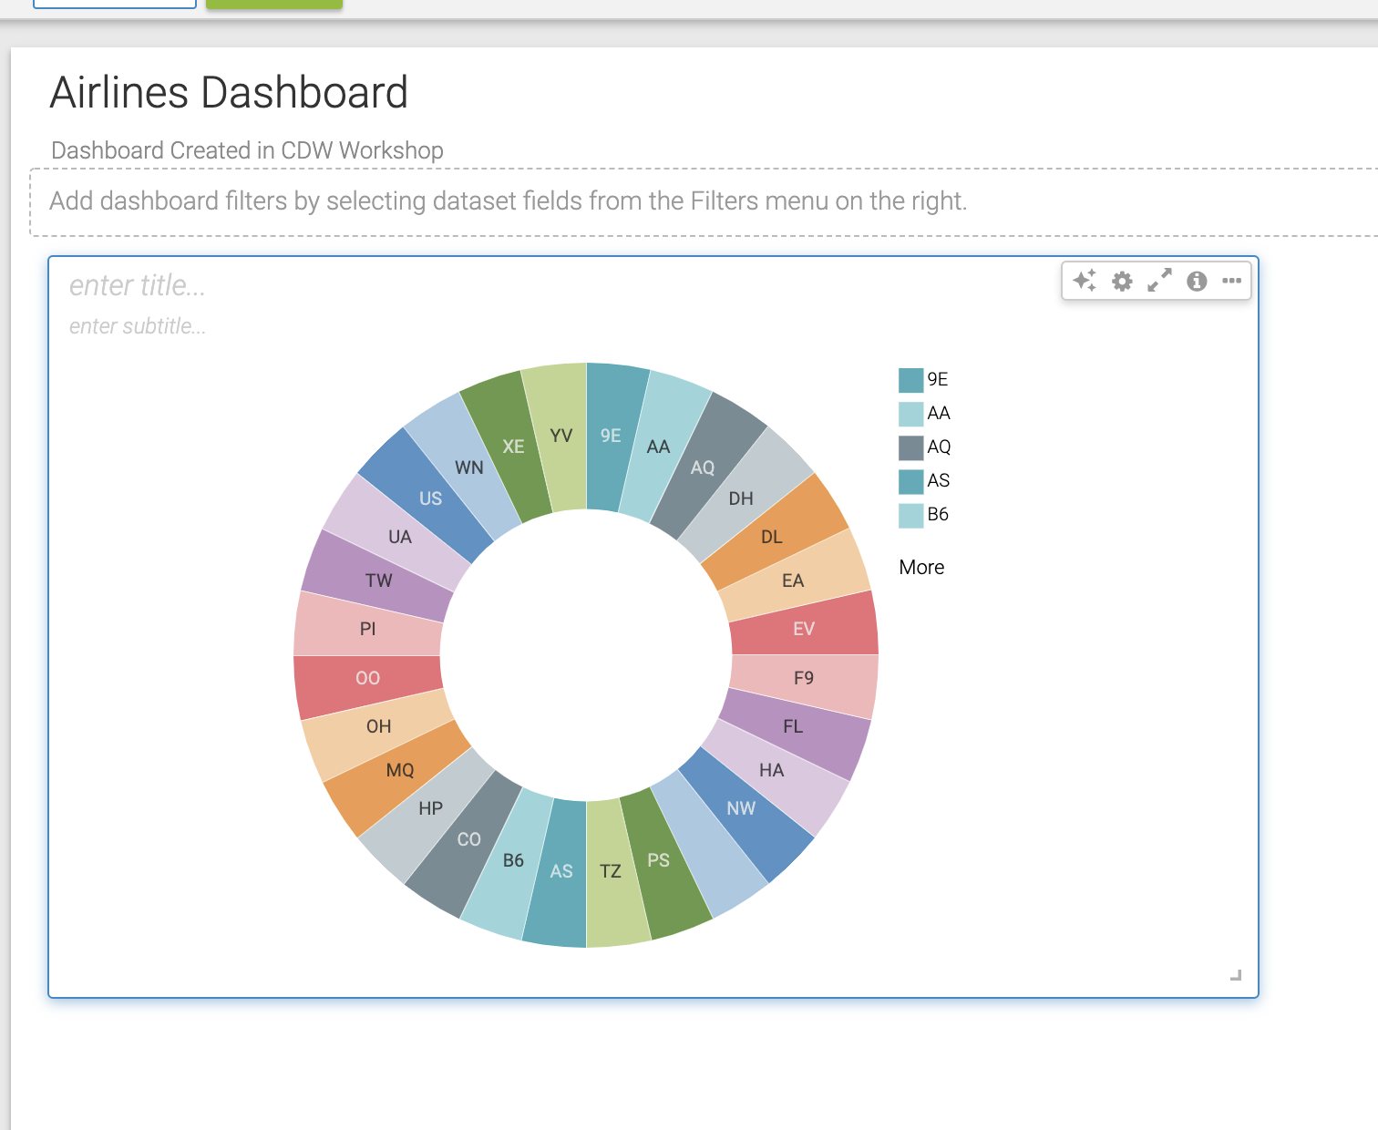

***Now you are aware how simple it is to create appealing HUE dashboards . Spend some time on this interactive HUE dashboard designer and try your hands on creating some impressive HUE dashboards.***

# Lab 2 – Iceberg Demo

# Create Iceberg Table Feature

Create table (partitioned) feature

* Execute the following lines in HUE for the Hive VW

CREATE EXTERNAL TABLE **<username>**.flights_icebreg (

month int, dayofmonth int,

dayofweek int, deptime int, crsdeptime int, arrtime int,

crsarrtime int, uniquecarrier string, flightnum int, tailnum string,

actualelapsedtime int, crselapsedtime int, airtime int, arrdelay int,

depdelay int, origin string, dest string, distance int, taxiin int,

taxiout int, cancelled int, cancellationcode string, diverted string,

carrierdelay int, weatherdelay int, nasdelay int, securitydelay int,

lateaircraftdelay int

)

PARTITIONED BY (year int)

STORED BY ICEBERG

STORED AS PARQUET;



SHOW CREATE TABLE **<username>**.flights_icebreg;



* + In the output - look for the following (see highlighted fields)

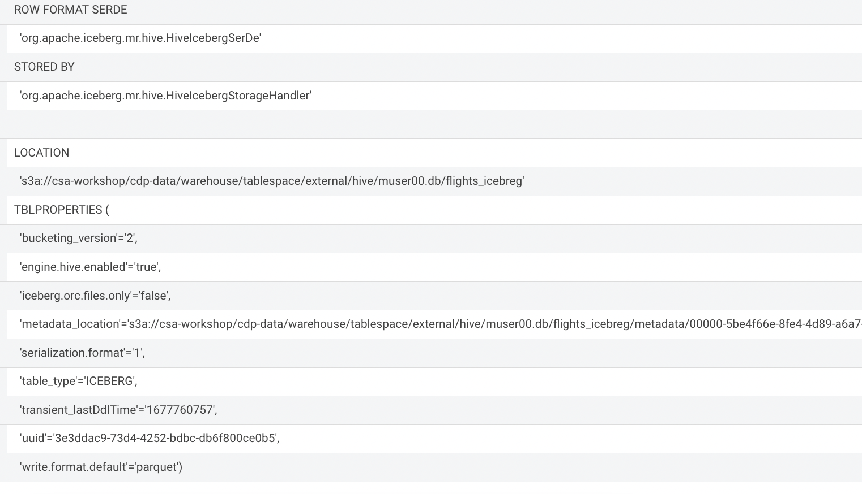

# Load Data into Iceberg Table

**Insert data feature**

* Execute the following lines in HUE for the Hive VW (this may take a few minutes)

INSERT INTO **<username>**.flights_icebreg

SELECT * FROM **<username>**.flights_ext

WHERE month <= 9;

SELECT * FROM **<username>**.flights_ext

WHERE month <= 9;



* + Once the load completes, execute the following query

SELECT month, count(*)

FROM **<username>**.flights_icebreg

GROUP BY month

ORDER BY month desc;



# Migrate Existing Tables to Iceberg Tables

* Execute the following in HUE for Hive VW, In the “user_id” parameter box enter your user id

show create table **<username>**.planes_ext;



* + In the output - look for the following properties Table Type, and SerDe Library

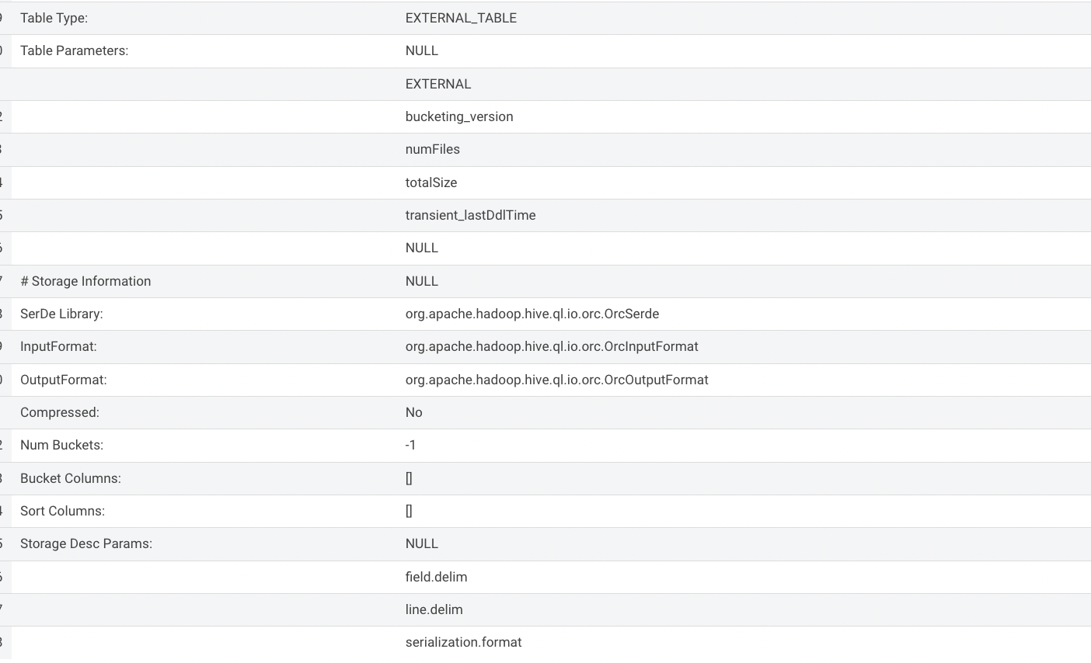

* + Execute the following

ALTER TABLE **<username>**.planes_ext

SET TBLPROPERTIES ('storage_handler'='org.apache.iceberg.mr.hive.HiveIcebergStorageHandler');



SHOW CREATE TABLE <username>.planes_ext;;



* + In the output - look for the following (see image with highlighted fields) key values: Table Type, Location (location of where table data is stored), SerDe Library, and in Table Parameters look for properties MIGRATE_TO_ICEBERG, storage_handler, metadata_location, and table_type
    - Location - Data is stored in cloud storage in this case S3 in the same location as the Hive Table Format
    - Metadata_location - Since there is no need to regenerate data files with in-place table migration, you save time generating Iceberg tables. Only metadata is regenerated, which points to source data files. Removes Hive Metastore as bottleneck.
    - Table_type - indicates “ICEBERG” table format
    - Storage_handler & SerDe Library - indicate what Serializer/Desearializer to use when reading/writing data in this case the “HiveIcebergSerDe”

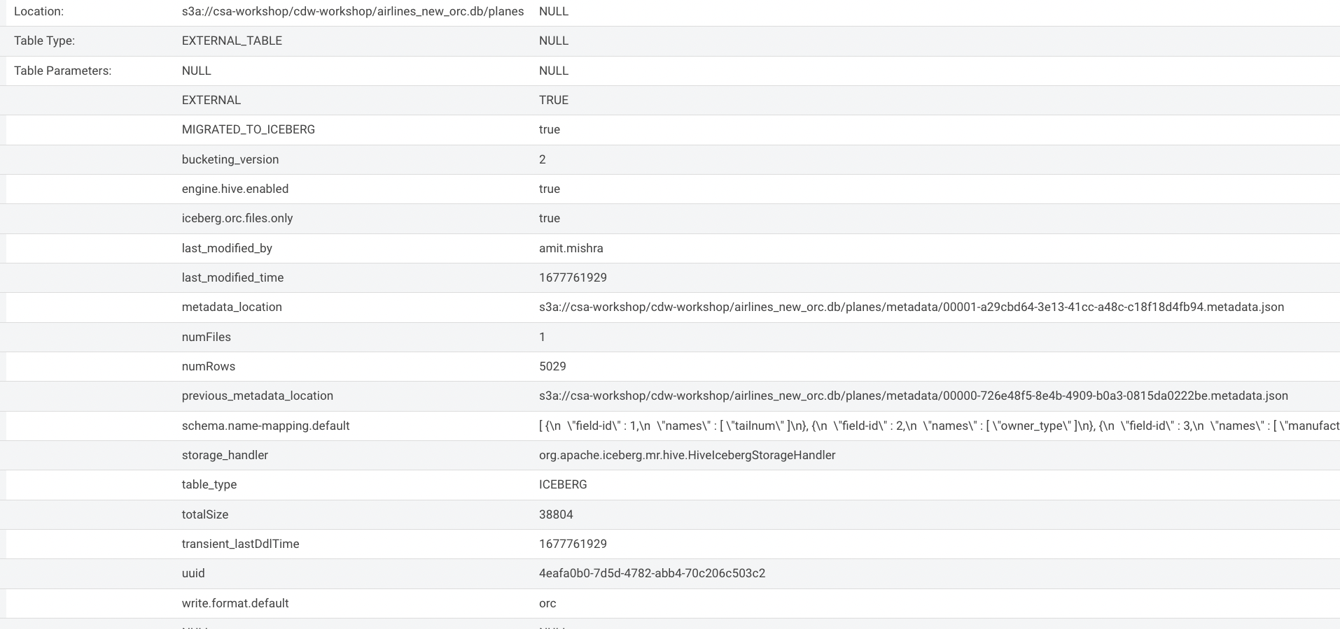

# Evolution (Partition & Schema)

In this Demo, we’ll just be exploring Partition Evolution.

**In-place Table Evolution feature**

* Execute the following lines in HUE for the Hive VW

ALTER TABLE **<username>**.flights_icebreg

SET PARTITION spec ( year,dayofmonth);



* + - **Note**: this ALTER TABLE happens in-place and no data is manipulated existing data remains indexed by Year
  + Execute the following

SHOW CREATE TABLE **<username>**.flights_icebreg;



* + In the output - look for the Partition Spec to see the table is now partitioned by Year & Month

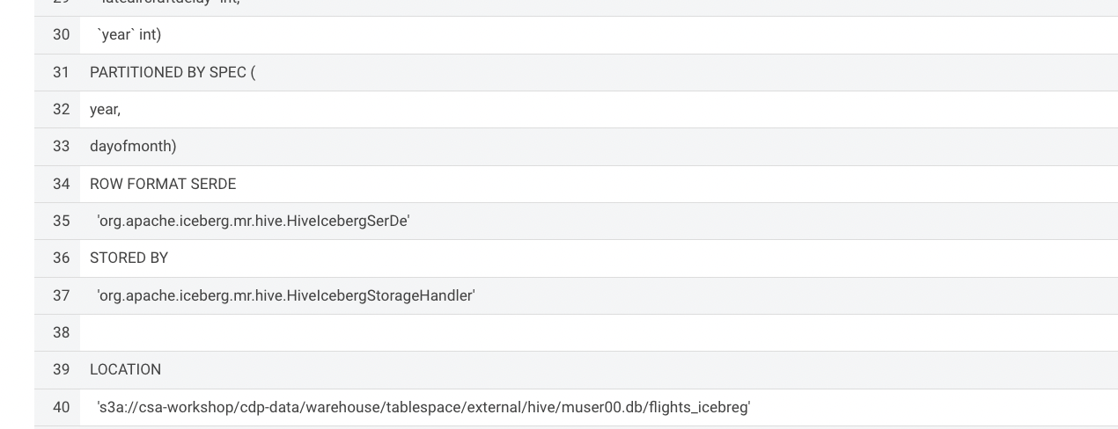

* + Execute the following lines in HUE for the Hive VW to load additional data into the flights table to leverage the new partitioning strategy

INSERT INTO **<username>**.flights_icebreg

SELECT * FROM muser00.flights_ext

WHERE month = 7;



**\*\*\*\*This concludes Cloudera DataWarehouse Workshop Lab \*\*\*\*\***